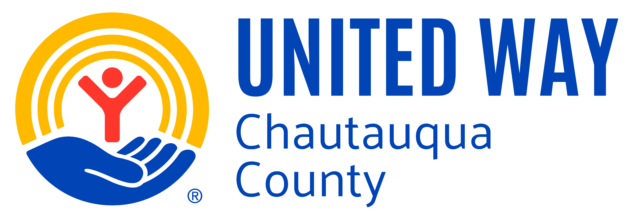
2025 CAMPAIGN REPORT FORM
208 Pine Street, Jamestown, NY 14701
www.unitedwaychq.org
Phone: 716-483-1561
E-mail: lsunday@unitedwaychq.org
Please Return Form By: November 21, 2025

Company Name: # of Employees:
Address:
City, State, Zip:
CEO: Phone: Email:
Business/Payroll Contact: Phone: Email:
Return to United Way by mail, email or request pick-up:
- ALL EMPLOYEE PLEDGE FORMS
- CASH AND/OR CHECK DONATIONS
- THIS FORM COMPLETED AND SIGNED

CORPORATE GIFT | Please enclose the signed Corporate Pledge Card  - Bill Monthly  - Bill Quarterly  - Bill Once on :______________________ (date) |  |  | $______________
EMPLOYEE GIFTS | Instructions | Number of Givers | Total 2025  Pledge/Donation Amount
1) Cash | Include original employee pledge forms, copies of pledge forms, or a spreadsheet summarizing employee pledges. |  | $
2) Checks |  |  | $
3) Payroll Deduction | - Invoice Monthly  - Invoice Quarterly  - No invoice required |  | $ | If you would like to receive this bill electronically, please indicate an email address here:
4) Other | This may include electronic pledges received or individual “Bill Me” pledges. It may include other kinds of fundraising like games/jeans days, 50/50 etc. |  | $
Additional Notes
Total Employee Gifts | Please total rows above.  All pledge cards must be signed by donors. |  | $  (Employee Gifts)*  Including other fundraising | $  (Corporate Gift)
Authorized Signature: Date: ________________________

